TURNING POINTS IN A WOMAN’S PATH TO LEADERSHIP:
A RESEARCH COMPENDIUM

Lisa Harper, Meagan Darrow & Meghan Sullivan
Analytical Techniques for Public Service II
Marc Baldwin
The Evergreen State College
March 17, 2014

Table of Contents
Abstract 3
List of Tables/Figures 4
Introduction 5
Theories on Barriers to Women in Leadership 5
The Glass Ceiling 6
The Labyrinth 7
External and Internal Barriers 8
Research Strategy 9
Research Design and Methods 10
Phase I - Online Survey Data Collection 11
Phase II - Interviews with Women Leaders 12
Phase III - Data Analysis 13
Findings 15
Quantitative data 16
Qualitative Data 19
Opportunities Make The Difference. 20
Working hard at what you love pays off. 20
The importance of having role models and mentors. 21
Further Research 23
Conclusion 24
References 28
Table II: Survey Results: Significance of Factors .....................................................................30
Figure VII: Infographic of Survey Results 35
Appendix I: Survey 36
Appendix II: Interviews 44

Abstract
Women remain underrepresented in leadership positions across all sectors, and social and cultural constructs of leadership remain highly gendered. Much literature details barriers to women achieving leadership positions, differences in leadership styles of men and women, and strengths and weaknesses of the traditional male versus female leadership styles. Women’s leadership is a hot topic these days. Countless books and news articles prescribe ways for women to ‘lean in’ to leadership, in the name of enhancing women’s access to leadership positions as well as the status of women as leaders. Little research exists, however, describing how women become successful leaders. What turning points do they encounter that fundamentally alter the course of their careers? What supports are necessary in their home, family, community, and work environment to foster leadership development among women? Does it make a difference if a woman had strong female mentors, supervisors or even if their mother worked outside the home? These are the questions we set out to answer, first through a review of literature and then through our own research. Through our own mixed methods research we explore the “turning points” women experience through their lives that they felt helped them gain their leadership position. We surveyed more than 250 women in the public and nonprofit sectors electronically and conducted 7 face-to-face interviews with local women leaders. In our research, 9 factors proved significant in determining whether a woman is a leader (supervisory or hire/fire authority) in her workplace. These factors speak to organizational factors such as promotion from within, a culture that encourages women to lead, and access to training. In addition, women who had female mentors were more likely to be leaders when compared to those who had a male mentor. Further, our interviews with women also illuminated the significant factor mentors can play in a woman’s career path. This research serves as a call to action for agencies, leadership groups, leaders, and women themselves.

List of Tables/Figures
- Figure I: Employment Sector and Education Level Survey Demographics…………Pg. 14
- Figure II: Age Range and Home Life Survey Demographics……………………….Pg. 14
- Figure III: Impact of Parents Survey Analysis………………………………………Pg. 16
- Figure IV: Anatomy of a Woman Leader Survey Analysis………………………....Pg. 17
- Figure V: Interview Responses………………………………………………………Pg. 19
- Table I: Themes mentioned in open-ended survey questions………………………..Pg. 22
- Figure VI: What could most aide women in advancing their careers? ……………...Pg. 22
- Table II: Which factors were significant in determining whether respondents were leaders (had supervisory or hire/fire authority) or not? ……………………………………..Pg. 28
- Figure VI: Infographic of Survey Results…………………………………………...Pg. 33

Introduction
In spite of progress in the public and nonprofit sectors, women remain underrepresented in leadership positions, both nationally as well as within the local Thurston County region. Because of this underrepresentation, women’s unique skills and talents remain underutilized in many sectors, including in nonprofit and government settings working to further the public good.
Stivers’ work, Gender Images in Public Administration (2002) points to a gap in the research and discussion about gender in public administration. Stivers concludes because the public and nonprofit sectors are thought to have a more balanced distribution of women in leadership positions, gender is often left out of the conversation. In reality women still hold only 31% of the public sector leadership positions in the United States (Ernst & Young, 2013). Although more balanced than the private sector, women still face barriers to reaching the highest level of leadership within public and nonprofit agencies. Much of the research about women in leadership has focused on theories explaining why women are not attaining leadership positions despite their gains in education. Frustrated by the focus on barriers and seeking a strengths-based approach to the gender disparity in leadership, we began to ask questions. ‘What can be done to empower women leaders, and transform the status of women as leaders,’ we wondered? ‘How can we mitigate identified barriers to women’s leadership, and improve the leadership experience of women leaders in nonprofit and governmental organizations?’ These questions drove us to conduct our own research with a transformational intent.

Theories on Barriers to Women in Leadership: A Review of Literature
With the 2013 release of Sheryl Sandberg’s book Lean In: Women, Work and the Will to Lead (2013), women’s equality in the workplace is on pop culture’s mind. Sandberg, Facebook’s Chief Operating Officer and one of Fortune 500’s most powerful women, suggests women must change the way we do things to be awarded top positions. Her tone and “practical advice” for women leaders assume women do not innately possess or have not acquired skills to be successful in breaking through the “glass ceiling.”

The Glass Ceiling
Coined in the 1980s, the glass ceiling metaphor was widely used throughout the 1990s to describe the barriers women face to attaining executive leadership positions within organizations. Even today it is a widely accepted concept. The glass ceiling refers an unseen barrier preventing women from advancing into upper management. In 1991 the Federal Glass Ceiling Commission formed to identify some of those barriers for women and minorities. The Commission studied barriers and opportunities in three areas: 1) the filling of management and decision making positions; 2) developmental and skill enhancing activities; and 3) compensation and reward systems (U.S. Glass Ceiling Commission, 1995). They also examined the educational and developmental preparedness of minorities and women to advance to management and decision making positions (U.S. Glass Ceiling Commission, 1995).
The Commission determined significant attitudinal and organizational bias prevented women and minorities from advancement. Barriers such as inadequate recruitment practices, lack of opportunity to contribute to and participate in corporate development programs and lack of top level ‘ownership’ of equal employment opportunity principles prevented women from accessing leadership positions. (U.S. Glass Ceiling Commission, 1995). The Commission identified multiple strategies to ‘shatter’ the glass ceiling “once and for all,” including carefully monitored management development plans, increased emphasis on the recruitment of qualified women and minorities, and corporate-wide diversity training and awareness programs (U.S. Glass Ceiling Commission, 1995, p. 11). All of these strategies rely on commitment from top management to remove barriers to equal access in upper level positions (U.S. Glass Ceiling Commission, 1995).
However, recent research criticizes the glass ceiling metaphor for failing to incorporate the complexity of challenges women face in obtaining leadership positions. The metaphor implies all women face a single, uniform obstacle and assumes women and men have equal access to entry- and mid-level positions before hitting the ceiling. Thus, those trying to ‘shatter the ceiling’ focus their interventions on too narrow a set of barriers, missing women who are discriminated against in lower level positions. Further, the interventions fail to address the prejudices against women in leadership across organizational levels and assume women don’t need any support once leadership is achieved.

The Labyrinth
Newer than the glass ceiling is the labyrinth metaphor, better representing the complexities of a woman’s journey complete with unexpected twists and turns (Eagly & Carli, 2007). Perhaps a more accurate description of the barriers women face, the labyrinth metaphor recognizes differences in the ways women and men achieve leadership roles, in part created by an unequal balance in power and opportunity (Eagly & Carli, 2007). The various paths to leadership twist and turn, are unpredictable, and have end points often obscured from view. When a woman successfully navigates the labyrinth, she and others who made it to the center can only see each other and not those who failed to solve the leadership maze or are currently struggling (Eagly & Carli, 2007). Further, the labyrinth’s organic and evolving nature makes it more difficult to maneuver.
This metaphor implies organizations may need to uproot and replant entire structural systems to create fairer avenues for success. Also, an organization’s labyrinth walls could be trimmed back to allow more visibility for the participants. Workers and managers have to agree to work toward a progressive evolution of their organization in order to significantly shift the work culture to create equal access to leadership (Eagly & Carli, 2007).

External and Internal Barriers
In examining the labyrinth metaphor, the types of barriers faced by women merit further examination. For example, societal norms and cultural traditions impose structural and cultural barriers, as well as impact women’s own constructs about gender and leadership. Further, women’s own fears and perceptions strongly influence their drive (or lack of drive) to seek leadership positions, constituting an ‘emergence gap.’ Finally, how they are received, supported and compensated as leaders also factors into the equation.
Pervasive external barriers in the form of societal norms and unequal pay exert a significant influence on women’s perceptions. For example, traditional gender roles as applied to occupation tell us nursing and teaching are more traditionally women’s work, while the roles of doctors, lawyers and politicians traditionally fall to men. Further, despite great cultural transformation from women entering the workforce to more egalitarian models of sharing child rearing and domestic chores, women still perform the majority of home and childcare, even in situations where both adults work full time (Caprino, 2013).
Still, society seems to pass judgment on women whether they stay at home with their children or work full time. For example, when Minnesota Democrat Amy Klocuchar ran for a Senate seat, people kept asking ‘what was going to happen’ to her children if she were elected (Newton-Small, 2013). In our own work experience, colleagues have asked us if we would rather be at home than at work full time, implying the home life responsibilities including cooking, cleaning and raising of children should take precedence over a woman’s career, or that women should want to be at home as opposed to out in the workforce.
This ‘double bind’ women find themselves in (Jamieson, 1995), and these kinds of inappropriate comments and behaviors, as well as other overt and subtle displays of “casual chauvinism and old-fashioned views of gender roles still pervade everyday life,” (Lawless & Fox 2010). Despite great gains in the past 50 and 100 years, the marginalization of women remains “more common than we want to admit” (Caprino, 2013). We know women must internalize these cultural and societal cues, but just what does this internalization look like and how is it affecting women and leadership? To answer this, we must closely examine internal barriers.
Countless internal barriers emerge to prevent women from leading, too. Due in large part to traditional socialization and ‘typical’ female gender role experiences previously described, many women lack in self-efficacy, (Hackett & Betz, 1981) and just plain lack interest in assuming leadership roles (Lawless & Fox 2010). Among college age women, self-esteem and even fears of negative evaluation limit young women’s leadership aspirations (Boatwright & Egidio, 2003).
With traditional gender roles profoundly impacting the emergence of female leaders, women are less likely to perceive themselves as leaders (Kent & Moss, 1994) and less likely to emerge as leaders. Thus, women’s own perceptions and ideations reduce the likelihood they’ll seek leadership positions, creating an emergence gap, however lack of appropriate role modeling of strong female leaders likely also impacts this complex set of issues.

Research Strategy
This research project aimed to elicit information from women leaders to help aspiring and current female leaders experience success both in gaining access to leadership roles and excelling as leaders. Through this work we sought to turn the barrier-focused research on its head, instead focusing on the factors or conditions helpful to women in their path to leadership. If critical turning points could be identified and better understood, perhaps we could build up on what works and employ a strengths-based approach to transforming the status and condition of women as leaders. Our specific questions were: ‘What “turning points,” events or factors, in a woman’s life helps them attain a leadership role?.’ and ‘which factors are most influential?’ Our assumptions in asking these questions were as follows:
- Women experience “turning points” that help them to achieve leadership positions
- Women’s leadership styles are different AND have a place in the public sector
- Knowing the turning points will help us understand how to improve the status of women as leaders in the public and nonprofit sectors, supporting women to access leadership positions and be successful in them.

Research Design and Methods
We conducted our research via a mixed methods approach with a transformational intent, utilizing a multistage, or cluster sampling design. The format is ideal due to the impracticality of identifying a comprehensive list of all women in leadership positions within nonprofit and governmental agencies in Washington (Creswell, 2014, p. 158). Though our goal was to survey approximately 75 women leaders in management or director-level positions within nonprofit and governmental organizations, our survey reached over 250 women, thanks in large part to the support and partnership of Washington State’s Interagency Committee of State Employed Women (ICSEW). All data were collected between January 17 and February 13, 2014.

Phase I - Online Survey Data Collection
We conducted first phase of research using an online survey of women leaders from public/government and nonprofit organizations via Google Forms. For the purposes of this research, we defined “leader” narrowly: women who supervise one or more staff, or have the authority to hire and release staff. Our survey tool included 34 multiple choice, Likert scale, and open-ended questions. Survey questions sought information on women’s perceptions about gender and access to leadership, gathered demographic information, and asked about social and workplace supports.
Using the snowball method, we distributed the survey by email to women employed in various public/government and nonprofit agencies using our own networks, and asked them to share the survey with others; this allowed us to reach a wide-range of individuals (Creswell, 2014). In addition, we partnered with the ICSEW to reach more many women in state government. The ICSEW’s support was extremely valuable; in the end 90% of our respondents represented the public sector while 10 % were from the nonprofit sector.
Although we were able to reach a large group of women in the public and nonprofit sector, we must acknowledge the limitations of using a snowball sampling method. Due to the limitations of our project including time and resources available, a snowball sample was our only option. Once our survey was sent to our networks and the ICSEW we had no control over who took our survey and so we cannot guarantee our sample is representational of the population of women in the public and nonprofit sectors. In addition, we are aware of the risks of sampling bias with our sampling method. The women likely to receive and take our survey were more likely to be already interested in the topic of women’s leadership and gender inequality in the workplace, so it is likely they share similar characteristics. As we analyzed our data we kept these limitations of our sample in mind.

Phase II - Interviews with Women Leaders
In addition to survey data collection, 7 women leaders participated in in depth one-on-one interviews between January 20 and February 7, 2014, overlapping with the survey data collection timeline. These focused interviews provided our research team with the opportunity to explore individual women leaders’ stories, identify themes, and collect rich qualitative information to inform our research (Rea & Parker, 2005, p. 73). The construction of questions was intentionally open-ended to allow us to explore women’s thoughts and feelings about their path to leadership without inserting too much structure or too many limitations (Creswell, 2014, p. 190). Questions explored what their career trajectory and education looked like prior to attaining a leadership role, as well as asked about turning points, factors and events or conditions women identified as exerting a significant impact on their trajectory. Further, interviews allowed an opportunity for women leaders to share thoughtful and meaningful advice for young women leaders, aspiring young women leaders, and all those seeking to support women in their careers.
As we identified whom to interview, an effort was made to select women representing agencies and organizations with diverse structures and makeup. Through the survey data collection we invited women to provide contact information at the end if they were willing to be interviewed, though no promise of an interview was made. Some interviewees participated in the survey first, providing their contact information for possible inclusion in the surveys, while other interviewees were referred by colleagues, and still other women were personally identified as having the potential to offer a great deal of information and insight to our research. Three women were interviewed from the public/government sector and four participated from nonprofit sector.
Interviewees ranged from 30-somethings to in their late 60s. All interviews were conducted in person and ranged from approximately 45 to 90 minutes in duration. Though all interviewees consented to our use of an audio recording device to record responses to the interview, we promised not to identify the women by name or agency in our results without obtaining additional consent. Further, we pledged to destroy all audio files and notes at the conclusion of our research.

Phase III - Data Analysis
Both our survey and interviews produced a wide breadth and depth of quantitative and qualitative data. Though our survey contained categorical and qualitative data points, we looked first at the quantitative data, downloading it from Google Forms into SPSS for analysis. Much of the initial data analysis centered around descriptive statistics, enabling a better understanding of the women leaders who took our survey. Through this initial analysis, we were able to describe the women leaders in various ways, including: age, employment sector, years in current position, whether these women had a mother or father who worked outside of the home, child/family care situations, level of education achieved, etc.
A wide variety of women participated in our survey. They ranged in age from 20 to age 69, and had a variety of levels of education, the majority with college degrees. Most survey respondents were married, and over half (51%) are parents of children still living at home. Nine out of ten (90%) women reported their fathers worked outside of home when they were growing up, compared to just 3 in 5 (59.4%) reporting their mothers worked outside the home. Figures 1 and 2 on the following page offer a visual display of key demographic information.

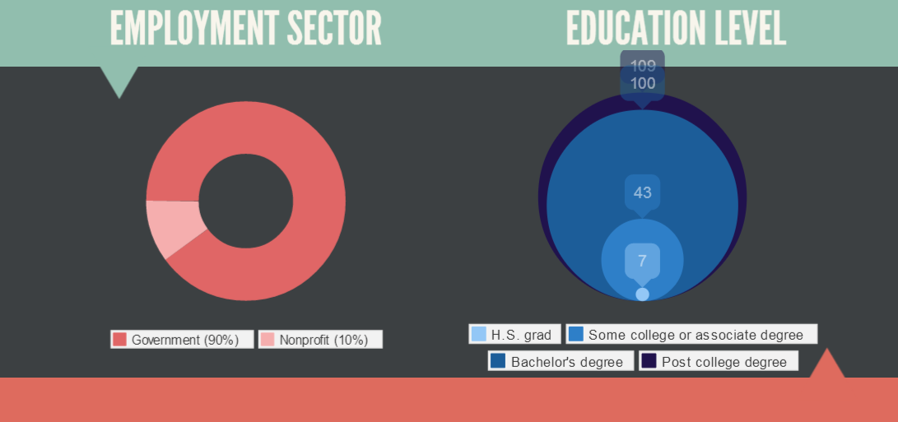
Figure I: Employment Sector and Education Level Survey Demographics

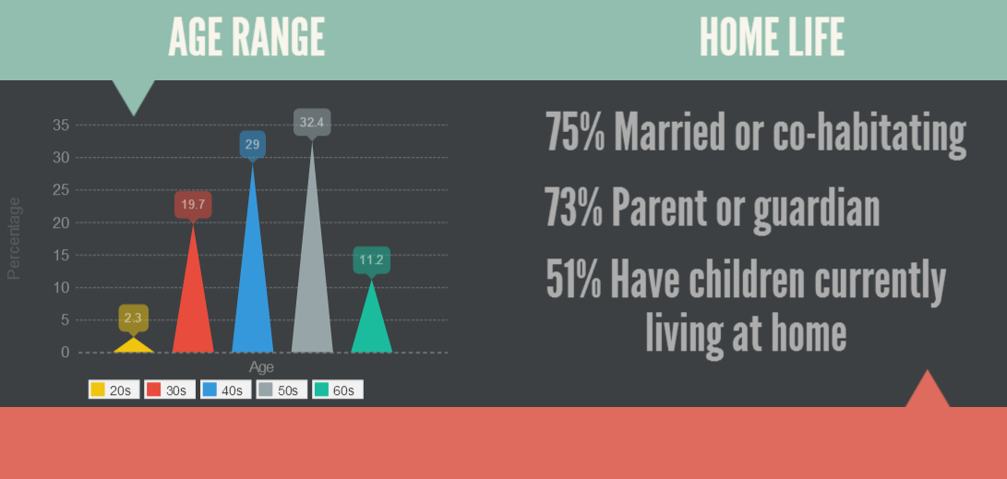
Figure II: Age Range and Home Life Survey Demographics
Although we sought to survey women who fit our specific definition of leader (supervisory or hire/fire authority) we ended up with many survey results from women who did not meet that definition. We were able then to divide the survey data into two groups: leaders (by our definition) and those who were not leaders by our definition. With two groups of women and all of the factors we asked about in our survey, group comparisons with crosstabulations and chi-squares made perfect sense. The other two natural ways to divide our data is by women who work in the public sector and women in the nonprofits. Although our numbers for nonprofit women who took the survey are low (10%) we were still able to run some chi-squares.
For example, we asked survey respondents to rate the impact of several events or factors on their career trajectories. From that data we analyzed which factors had impact on women leaders by using chi-square test to discover if there is a relationship between two categorical variables. One variable is our “leader Yes/No” and the other variables are all of our other survey questions, each aimed to determine factors that influenced whether women become leaders:
➔ Are women who had mentors more likely to be leaders?
➔ Which factors in their career path were chosen as the most influential by women leaders?
➔ Do opinions among women in the public sector versus in the nonprofit sector differ in terms of which factors were more influential in helping them to achieve leadership positions?
➔ Which groups of people (spouse, children, parents, etc.) had the most positive impact on women leaders’ paths to their careers? Which exerted the least impact, or did any exert a negative impact?
➔ Do women leaders in nonprofits and the public sector have differing perceptions of the level of organizational or social support they experience with respect to serving in a leadership capacity?

Findings
Our quantitative survey and qualitative data turned up a lot of expected results, as well as some surprises. By analyzing the 53 factors in our survey for group differences between women leaders (by our definition) and women not in leadership positions we found 9 factors to be statistically significant between the groups, indicating a relationship. By determining those statistically significant factors we were able to paint a picture of some of the common characteristics of a woman leader.

Quantitative data
We hypothesized that whether or not a woman’s mother worked outside the home while she was growing up would be correlated to whether a woman was a leader, however we found no significant relationship between women who are leaders by our definition and whether their mothers worked outside of the home c² (4, N = 259) = 3.849, p = .427.
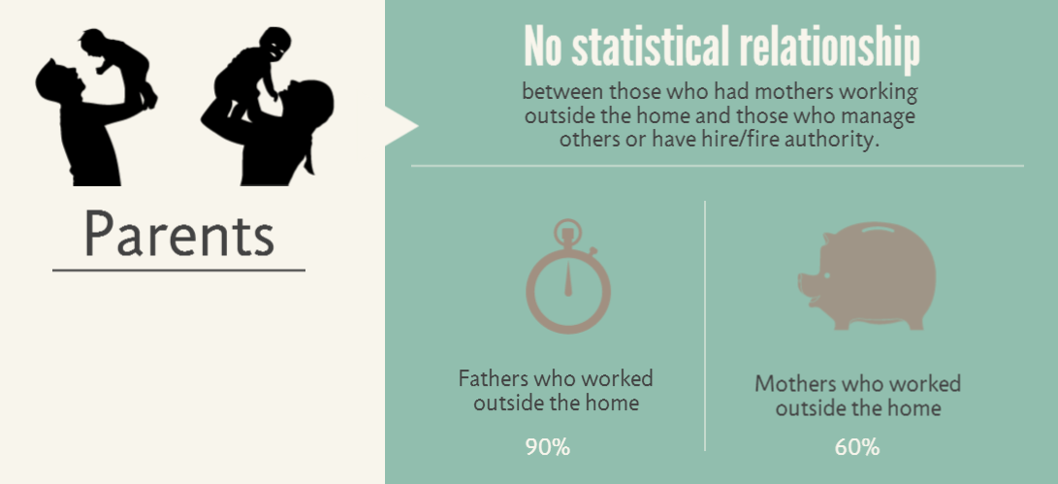
Figure III: Impact of Parents Survey Analysis
Women rated the impact various factors and turning points had on their career path, including things like education, network of support, and wanting more money, for example. By calculating Chi-Square significance, only three factors registered as correlated to whether the survey respondents were leaders by our definition:
- workplace training opportunities c² (4, N = 259) = 12.645, p = .013,
- the organization had a need the respondent was able to fill c² (4, N = 259) = 14.104, p = .007, and
- work experiences positioned them to become a leader c² (4, N = 259) = 14.736, p = .005.
In addition, women leaders by our definition were more likely to indicate a support network of friends and family had a major impact on their ability to obtain a leadership position than women not in leadership positions c² (4, N = 259) = 10.475, p = .033.
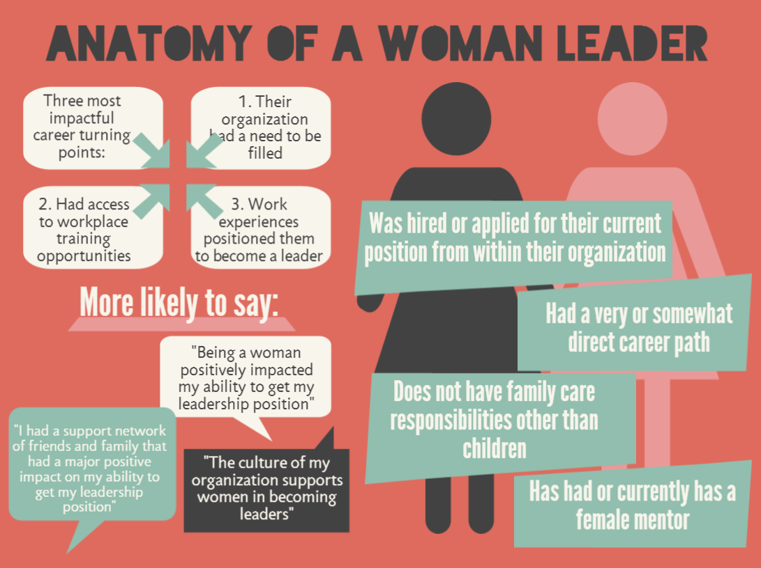
Figure IV: Anatomy of a Woman Leader Survey Analysis
When we compared the women who work in government with women working in nonprofit settings using the same categories of turning points in their careers, the factors that had relationships were:
- changing fields/career trajectory (an aha! moment) c² (4, N = 259) = 12.031, p = .017 and again,
- workplace training opportunities c² (4, N = 259) = 9.862, p = 043.
Of those two factors, those working for nonprofits were both more likely to say “workplace training opportunities” had an influence on their careers and that having an aha! moment had a major impact on their career trajectories.
Women leaders were more likely to say having a female supervisor was definitely or somewhat helpful in them obtaining a leadership role, although whether or not they had ever had a female supervisor was not a statistically significant relationship c² (1, N = 259) = .191, p = .462. This finding leads us to think about those female supervisors - what made some of them so significant in women leader’s career paths and some of them not in the lives of women who are not leaders? Looking at more organizationally focused factors, women leaders were more likely to say the culture of their organization supports women to become leaders. And women leaders were more likely to have been promoted within vs. being hired from outside the organization. These significant factors together suggest an organization that works to support women in obtaining leadership positions is successful in their pursuits.
Our research also looked more closely at the role mentors may have played in these women’s careers. Although no significant relationship appeared between whether a woman is a leader (by our definition) and whether they had a mentor c² (1, N = 259) = .859, p = .226, a significant relationship is evident between whether a women is a leader and whether they had a female mentor c² (3, N = 259) = 8.679, p = .034.
In the domain of personal beliefs and perspectives, family life, and attitudes about their career paths, women leaders in our survey were more likely to say that being a woman positively affected their ability to obtain a leadership role. Although no statistically significant relationship was identified between whether women turned down a job or took time off due to family care responsibilities, women leaders who took our survey were less likely to have regular family care responsibilities other than children than the non-leader women who took our survey.

Qualitative Data
Our qualitative data included open-ended questions from 225 applicable survey responses as well as extended interviews with seven women leaders in government or nonprofits. In our interviews we expected to see that the women who were leaders consistently had a supportive partner, especially if they had kids, but at least a couple of the women we interviewed specifically said they did not have that support at home.
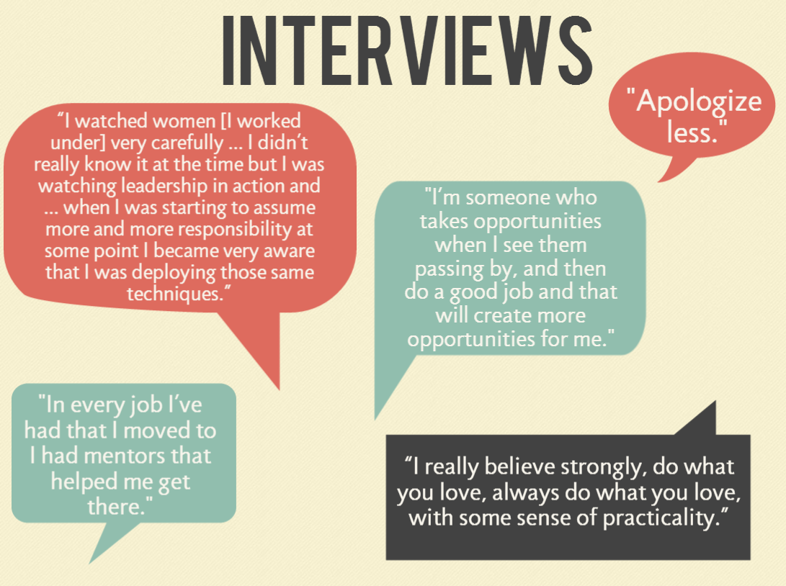
Figure V: Interview Responses

Theme 1: Opportunities Make The Difference
The theme of opportunities making a difference was mentioned in our survey 50% of the time. Certainly anyone who would like to be a leader needs opportunities to get there, but perhaps those opportunities that are so available for men are not so readily available for women. Although the opportunities women said were needed varied, the concept of needing opportunities in general speaks to a greater need to help women. These include opportunities to observe women leaders (role models), opportunities for internships, opportunities for training, etc. That women need help to succeed and get leadership positions was one of the assumptions we had going into the survey and interviews. Some key phrases from our survey and interview respondents:
● “Women need opportunities for different kinds of leadership.” - survey respondent
● “Women need the opportunity to witness leading.” - survey respondent
● "See opportunity and take it. Give yourself permission to take a risk." - Executive Director of local Non-Profit
● “I never set a path for my career; I’m more someone who takes opportunities when I see them passing by, and then do a good job and that will create more opportunities for me.” - State-level elected official (b)

Theme 2: Working hard at what you love pays off
Another theme emerging from our interviews and survey data was this: to succeed women needed to do what they love and work hard at it. A lot of the women also mentioned that when you’re doing what you love, you had to stop apologizing for it. A few quotes reflective of these sentiments include:
● "Follow your passion. Know your career is a very long time, indeed." - Executive Director of local Non-Profit
● "Apologize less [for what you care about]." - Director of local Higher Education Institution
● “I really believe strongly, do what you love, always do what you love, with some sense of practicality.” - State-level elected official (b)
● On how she rose up to become a leader: “I decided to mostly just do things I loved. If you love something you work harder at it and you do it better and with more joy and happiness.” - State-level elected official (b)

Theme 3: The importance of having role models and mentors
All the women we interviewed and 40% of the women we surveyed mentioned mentors as either something they believed helped them achieve leadership positions and/or something women need to become leaders. Many of the responses indicated they didn’t have formal mentor relationships with women, but that at some point in their careers someone believed in them. In addition, all the women we surveyed had a belief that as leaders who had mentors helping them, they needed to help other women achieve success as well. Some selected quotes are below:
● Upon reflecting back on the earlier days of her career, she worked under three different female directors, and she said “I watched those women very carefully in how they did their work ... I didn’t really know it at the time but I was watching leadership in action and twenty years into my career when I was starting to assume more and more responsibility at some point I became very aware that I was deploying those same techniques.” - Local-level elected official
● “The only way you can repay (women who helped you) is by doing the same for someone else." - Director of local Higher Education Institution
● “In every job I’ve had that I moved to I had mentors that helped me get there. They weren’t necessarily people I chose as mentors, but they were definitely people who believed in me and who believed I could do more.” - State-level elected official (b)
A summary of themes mentioned in open-ended survey questions is reflected in the table below by percentage of responses.
Theme | # of responses | Percentage
Opportunity Makes The Difference | 86 | 38%
Work Hard at What you Love | 43 | 19%
Mentors/role Models | 93 | 40%
Total Responses | 225 | 100%

Table I: Themes Mentioned in Open-Ended Survey Questions

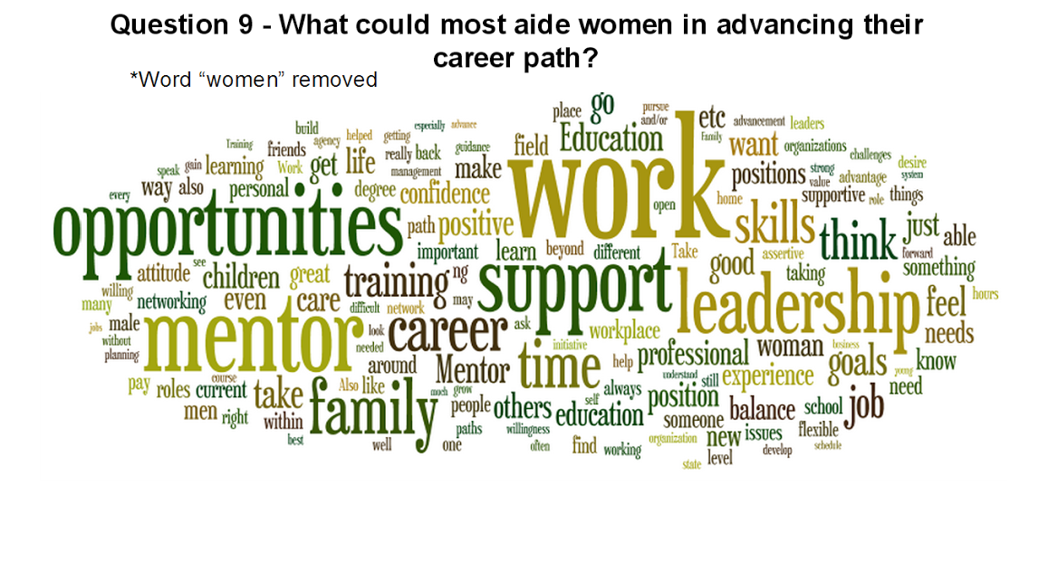
Figure VI: What Could Most Aide Women in Advancing Their Careers?

Further Research
To conclude our survey, we asked women “do you consider yourself a leader?” Overwhelmingly respondents said yes and wrote about how they work with other people and staff in their agencies to produce good work. Some for example work in higher education, and while they do not necessarily directly supervise or hire/fire staff, they engage in many leadership tasks and functions. In light of this, we realized after concluding our survey that our narrow definition of leadership did not capture the entire picture of what leadership is. Although it was necessary for our survey we would recommend additional research into the meaning of leader and how we can encourage women to pursue leadership opportunities in many aspects of their lives and organizations, as many formal and informal leadership roles are vital to a successful and prosperous society.
In our interviews many women spoke about the importance of having self-confidence, a strong work ethic and a passion for their work as factors leading to their current leadership roles. We did not capture these factors in our survey and were thus unable to capture whether they ring true as significant factors for other women leaders. Thus, we recommend further research into how more personal factors contribute to women becoming leaders.
Although we determined female mentors and role models played a significant role for our interview subjects and for the women leaders in our survey, we never defined mentor/role model specifically. In our interviews we saw a continuum of mentors - from watching a woman manager to a formal mentor relationship to a boss who helped created opportunities. In light of this, the conclusions we can draw from our survey are limited; as such, we recommend further research into what types of mentor/mentee relationships can be most beneficial for women.
Our research also indicated organizational cultures supportive of women, as well as agencies that provide women with relevant experiences that helped to position women as leaders influenced women, helping them to become leaders. Further research is needed to find out what it is about organizations that make them supportive of women’s advancement and what differences there are between organizations that are perceived to be supportive of women leaders and those that are perceived as less supportive or not at all supportive.

Conclusion
In spite of monumental progress towards gender equality in the past century, women are still left out or locked out of leadership positions in our nation and region, when compared to their male counterparts. This underrepresentation inhibits women’s ability to contribute their unique skills and talents to nonprofit and government leadership for the public good. By focusing our research not on the barriers per se, but on the turning points and leverage points, we sought to transform the status of women as leaders. As one woman leader astutely observed, however, sometimes a barrier is the fodder for refining one’s leadership skills and abilities, making a woman more resilient when she emerges from a challenging situation. The fact remains undisputed that there is work to be done to build resilience, create opportunities, and support women to access leadership positions and succeed in them. In looking at what can be done, we examine these opportunities in the context of organizational and individual domains.
In the Organizational context, women leaders were more likely to say the culture of their organizations supported women in becoming leaders. Of several powerful leverage or turning points in their careers women leaders were more likely to say they had access to workplace training and their work experiences positioned them to become a leader. In addition women leaders were more likely to have applied and/or been hired from within their organization for their current leadership position. The women leaders were not more likely to have or have had a mentor (most women did), but were much more likely to have had a female mentor, an idea that was echoed in our interviews.
Thus, organizations committed to supporting equal access to leadership by women and men can enhance their success by assessing their organizational culture, providing on the job training, offer opportunities for women to lead and engage in mentor relationships. By encouraging and allowing current women leaders to take time from their schedules to mentor the younger women in the organization, individuals thrive, teams thrive, and the organization thrives. Whether they be formal job shadowing, intern programs, formal mentorships or more informal methods such as encouraging/allowing women to take time from their days to reach out to younger women in the organization, organizations will grow stronger as their women employees grow. Further, by encouraging women interested in leadership to seek out opportunities for leadership and to observe leadership, organizations also position themselves ahead of other agencies. Young women who are seeking to be leaders can seek to position themselves in organizations that support women and have training opportunities and the ability for upward mobility. This also provides added benefit to an organization because when staff are trained and supported, they are ready to step up when a need emerges, making the job search quicker and easier because a qualified candidate is already on hand within the agency or department.
In the individual domain, several opportunities and calls to action also emerged. The women leaders we surveyed indicated a support network of friends and family had a major positive impact on their abilities to obtain their leadership position. All the women we interviewed indicated the importance of working hard at something you love and not apologizing for your passion and hard work. In addition, the women leaders were less likely to have family care responsibilities at home other than children (such as aging parents). The lessons we can learn from these factors are that women need a strong network of support to succeed as leaders. Women interested in leadership can actively pursue the creation and maintenance of a strong network of support to enhance their personal wellbeing and professional success. One opportunity to make this happen is to encourage women to seek support in their friends and families. Additionally, women who believe in themselves and work hard at what they care about succeed; thus, encouraging and supporting women need to pursue their dreams creates conditions for success. Women leaders we interviewed emphasized the importance of dreaming about their future, but also creating a plan of action to achieve those dreams. By creating a space for women to be around other women leaders, as this offers both a network of support, visible female role models help women, and a place to process ideas, dreams and plans. Through our research, we determined a blog and Facebook group were good ways to connect women leaders and aspiring women leaders across geography, so we have created both and intend to maintain them into the future. In addition, while the ICSEW is a great resource for women within Washington State government, one glaring gap that exists is a single reputable professional organization for women leaders. In light of this, our group is currently exploring the feasibility of forming a nonprofit organization dedicated to advancing the status of women leaders in the United States.
So, what does this mean for organizations? What about for women? Organizations can institutionalize these key findings by creating formal policies around mentoring, professional development and hiring from within when appropriate, job shadowing, or similar. Women leaders can be accessible, and lend a hand to women in their lives, teams and workplaces. They can give direct feedback and invest in training and developing young women leaders. Aspiring women leaders can advocate for themselves, dream, plan for their future, seek out supports and role models, and work hard at what they love without apologizing. In these ways, together we can create a world that better supports and empowers women, and enhances the status of women as leaders. To meet the growing challenges of our modern society, we must access and leverage all of the leadership available to create more just and peaceful world.

References
Boatwright, Karyn J. & Egidio, Rhonda K. (2003). Psychological Predictors of College Women’s Leadership Aspirations [Abstract]. Journal of College Student Development. 44(5), 653-669. Retrieved from http://muse.jhu.edu/login?auth=0&type=summary&url=/journals/journal_of_college_stu dent_development/v044/44.5boatwright.html

Caprino, Kathy (2013, February 12). The Top 6 Reasons Women Are Not Leading In Corporate America As We Need Them To. Forbes. Retrieved from http://www.forbes.com/sites/kathycaprino/2013/02/12/the-top-6-reasons-women-are-not- leading-in-corporate-america-as-we-need-them-to

Creswell, John W. (2014). Research Design: Qualitative, Quantitative, and Mixed Methods Approaches. (4th edition). Thousand Oaks, CA: Sage Publications, Inc.

Eagly, A. (2007). Female Leadership Advantage and Disadvantage: Resolving the Contradictions. Psychology of Women Quarterly, 31, 1-12. Retrieved from http://onlinelibrary.wiley.com/doi/10.1111/j.1471-6402.2007.00326.x/full

Eagly, A. H., & Carli, L. L. (2007). Women and the Labyrinth of Leadership. Harvard Business Review, 85(9), 62-71. Retrieved from http://citt.hccfl.edu/newsletters/newsletterid1.pdf

Ernst & Young. (2013). Worldwide Index of Women as Public Sector Leaders. Retrieved from http://www.ey.com/GL/en/Industries/worldwidewomeninpublicsector---overview

Global Institute of Internal Auditors (2011). Supplemental Guidance: Public Sector Definition. Retrieved from https://global.theiia.org/standards-guidance/Public%20Documents/
Public%20Sector%20Definition.pdf
Hackett, Gail & Betz, Nancy E. (1981). A self-efficacy approach to career development of women [Abstract]. Journal of Vocational Behavior. 18(3), 326-339. Retrieved from http://www.sciencedirect.com/science/article/pii/0001879181900191.

Ibarra H., Ely R., & Kolb D. (2013). Women Rising: The Unseen Barriers. Harvard Business Review, 91(9). http://dragonflyconsultants.net/wp-content/uploads/2013/09/HBR- Women-rising-The-unseen-barriers.pdf

Jamieson, Kathleen Hall (1995). Beyond the Double Bind: Women & Leadership. New York: Oxford University Press, 1995). p. 5.
Kent, Russell L., & Moss, Sherry E. (1994). Effects of Sex and Gender Role on Leader Emergence. Academy of Management Journal. 37(5), 1335-1346. Retrieved from http://www.jstor.org/stable/256675

Lawless, Jennifer L. & Fox, Richard L. (2010). It Still Takes a Candidate: Why Women Don’t Run for Office. New York, NY: Cambridge University Press.

Newton-Small, Jay (2013, October 16). Women Are the Only Adults Left in Washington. Time Magazine. Retrieved from http://swampland.time.com/2013/10/16/women-are-the-only- adults-left-in-washington/#ixzz2iEbzU3nO

Rea, Louis M., & Parker, Richard A. (2005). Designing & Conducting Survey Research: A Comprehensive Guide. (3rd edition). San Francisco, CA: Jossey-Bass.

Sandberg, S. (2013). Lean In: Women, Work and the Will to Lead. New York, NY: Knopf Publishing.

Stivers, Camilla. (2002). Gender Images in Public Administration: Legitimacy and the Administrative State. Thousand Oaks, California: Sage Publications.

U.S. Department of Commerce Economics and Statistics Administration. (2011). Women in America: Indicators of Social and Economic Well-Being. Retrieved from http://www.whitehouse.gov/sites/default/files/rss_viewer/Women_in_America.pdf

U.S. Glass Ceiling Commission (1995). A Solid Investment: Making Full Use of the Nation's Human Capital (Final Report of the Commission). Washington, DC: U.S. Government Printing Office. http://digitalcommons.ilr.cornell.edu/key_workplace/120/

Table II: Survey Results: Significance of Factors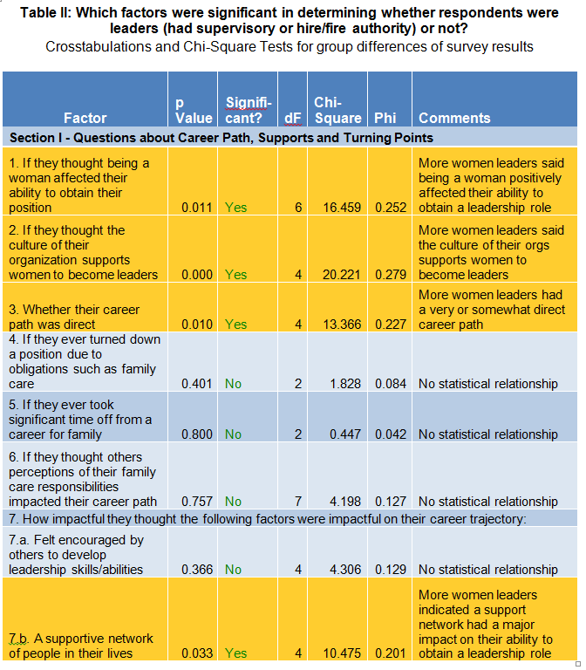

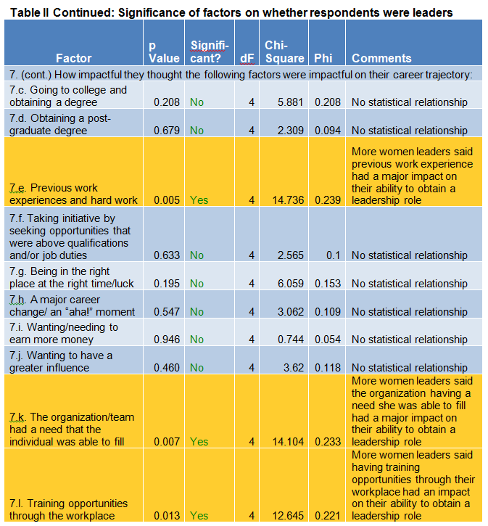
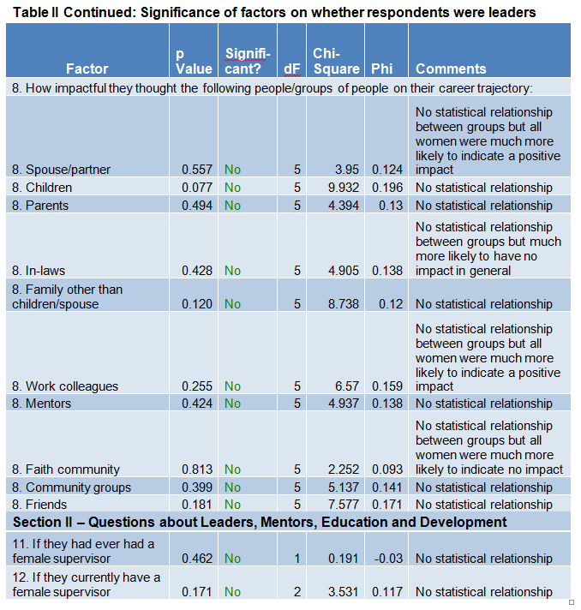

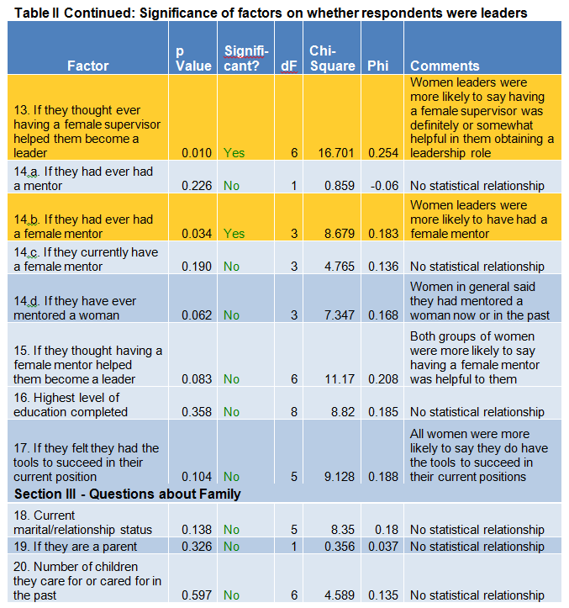

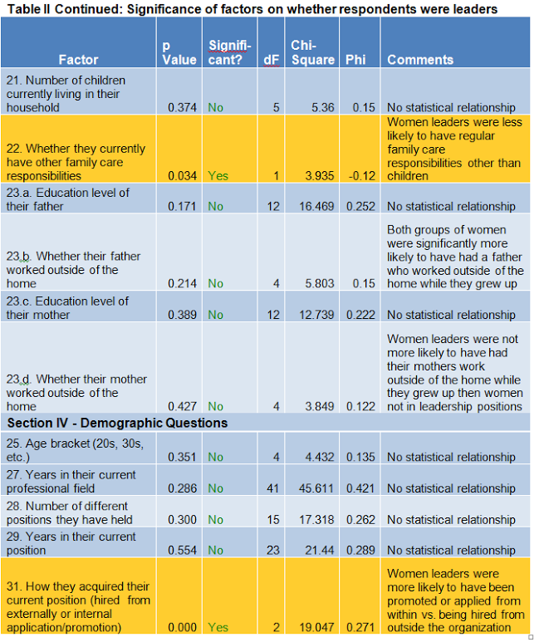

Figure VII: Infographic of Survey Results
Created with http://piktochart.com
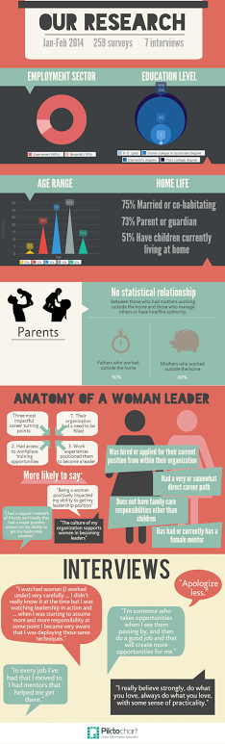

Appendix I: Survey
Understanding the Turning Points in a Woman’s Path to Leadership

Informed Consent for Survey

Thank you for taking time to complete this survey. Our aim is to better understand what specific turning points (events and/or factors) within a woman’s career help them achieve leadership positions. For the purposes of this survey, we define leadership as supervising one or more employees and/or have the power to hire or release staff from employment. The survey consists of 32 questions in 4 clearly marked sections and should take less than 15 minutes to complete.

This is a research project being conducted by graduate students in the Masters of Public Administration program at The Evergreen State College. You are being invited to participate in this research project because you are a woman in a leadership position within the public or nonprofit sector. Your participation in this research study is voluntary. You may choose not to participate. If you decide to participate in this research survey, you may withdraw at any time. If you decide not to participate in this study or if you withdraw from participating at any time, you will not be penalized. We will do our best to keep your information anonymous. All data is stored in a password protected electronic format. To help protect your anonymity, the surveys will not contain information that will personally identify you. The results of this study will be used for scholarly purposes only and will only be shared with The Evergreen State College students and faculty. If you have any questions about the research study, please contact Meagan Darrow at darmea04@evergreen.edu. This research has been reviewed according to The Evergreen State College IRB procedures for research involving human subjects.

We appreciate you taking the time to participate.

Electronic Consent: By selecting agree you consent to take this survey.

Section I - Career Path, Supports and Turning Points
1. Do you feel being a woman affected your ability to attain your leadership role? (select one)
Yes, positively
Yes, somewhat positively
Neutral
Yes, somewhat negatively
Yes, negatively
No
Unsure

2. Do you feel the culture of your organization supports women to become leaders? (select one)
Yes, definitely
Yes, somewhat
Neutral
No, not really
No, definitely not

3. Do you feel your career path to your current role was direct (for example, education led to first job, which led to next job, which led to an eventual leadership role)? (select one)
Yes, very direct
Yes, somewhat direct
Neutral
No, somewhat indirect
No, very indirect

4. Have you ever turned down a position because you had other obligations (e.g. family care, partner, children)? (select one)
Yes No

5. Have you taken significant time off (more than 1 month) from your career for family in the past (e.g. partner’s career, children, elder care)? (select one)
Yes No

6. Do you think others’ perceptions of your family care responsibilities impacted your career path? (select one)
Yes, positively
Yes, somewhat positively
Neutral
Yes, somewhat negatively
Yes, negatively
No
Unsure

7. What turning points (events/factors) have you experienced that positively impacted your career trajectory? Please rate what impact the following events/factors had on your career trajectory. (rate all that apply)

I felt encouraged by others to develop my leadership skills/abilities
0 1 2 3
No impact Minor impact Some impact Major impact

I had a network of people in my life who support me (friends, family, other)
0 1 2 3
No impact Minor impact Some impact Major impact

I pursued going to college and obtaining a degree
0 1 2 3
No impact Minor impact Some impact Major impact

I pursued/obtained a post-graduate level college degree
0 1 2 3
No impact Minor impact Some impact Major impact

Previous work experiences positioned me to become a leader (i.e. hard work)
0 1 2 3
No impact Minor impact Some impact Major impact

I took initiative in my job by seeking opportunities that were above my qualifications and/or job duties.
0 1 2 3
No impact Minor impact Some impact Major impact

I was at the right place at the right time/I got lucky
0 1 2 3
No impact Minor impact Some impact Major impact

I chose to change fields/change my career trajectory (I had an “aha!” moment)
0 1 2 3
No impact Minor impact Some impact Major impact

I wanted/needed to earn more money
0 1 2 3
No impact Minor impact Some impact Major impact

I wanted to have a greater influence
0 1 2 3
No impact Minor impact Some impact Major impact

My organization/team had a need that I was able to fill
0 1 2 3
No impact Minor impact Some impact Major impact

I had training opportunities through my workplace that provided me with new skills
0 1 2 3
No impact Minor impact Some impact Major impact

Thinking of the question above, where there any other experiences that positively impacted your career trajectory? If so, what were they, and how did they impact you? (fill in the blank)

8. On the path to your current position and in your current position, how do (or did) the following individuals or groups of individuals impact you? (rate all that apply)

Spouse/ partner
-1 0 1 2 3

Children
-1 0 1 2 3

In-laws
-1 0 1 2 3

Family (aside from spouse/ children) (e.g. grandparents, siblings)
-1 0 1 2 3

Work/professional colleagues
-1 0 1 2 3

Mentor(s) (formal or informal)
-1 0 1 2 3
Faith community
-1 0 1 2 3

Community groups or organizations
-1 0 1 2 3

Friends
-1 0 1 2 3
9. Thinking of your career path, what things do you personally feel could most aid a woman in advancing her career path? (fill in text box)

10. Within your organization (current or past), what do you think could be done to help women achieve leadership positions? (fill in text box)

Section II – Leaders, Mentors, Education and Development
11. Have you ever had a female leader/ supervisor? (select one)
Yes No

12. Do you currently have a female leader/ supervisor? (select one)
Yes No

13. If you had or currently have a female leader/ supervisor, do you think this helped you to become a supervisor? (select one)
Yes, definitely helped
Yes, somewhat helped
Neutral
No, didn’t really help
No, definitely didn’t help
n/a

14. Mentoring (please answer all that apply)
Have you ever had a mentor (formal or informal)?
Yes No n/a
If yes (you have had a mentor), have you ever had a female mentor?
Yes No n/a

Do you currently have a female mentor?
Yes No n/a

Have you ever mentored a woman (now or in the past)?
Yes No n/a

15. If you had or currently have a female mentor (formal or informal), do you think this helped you to become a leader? (select one)
Yes, definitely helped
Yes, somewhat helped
Neutral
No, didn’t really help
No, definitely didn’t help

16. What is the highest level of education you have completed (select one)
Less than High School
High School/GED
Some College
2-Year College Degree (Associates)
4-Year College Degree (BA, BS)
Master's Degree
Doctoral Degree
Professional Degree (MD, JD)

17a. Do you feel you have the tools (e.g social support, organizational support, professional development, etc.) to succeed in your current positions? (select one)
Yes, definitely
Yes, somewhat
Neutral
No, not really
No, definitely not

17b. If no, are you working to create needed tools or advocating to get those tools?

Section III - Family
18. What is your Marital/Relationship Status? (please check all that apply)
Single
Co-habitating
Married
Separated
Divorced
Widowed
Other: (fill in text box) _______________

19. Are you a parent or guardian? (select one)
Yes No

20. How many children do you (or did you generally) care for?
n/a (I am not a parent or guardian)
0 (I am a NON CUSTODIAL parent)
1
2
3
4
5 or more

21. How many children still live in your household most or all of the time?
n/a (I am not a parent or guardian)
0 (I am a NON CUSTODIAL parent)
1
2
3
4
5 or more

22. Do you currently have other family care responsibilities (such as regularly helping a parent or grandparent)? (select one)
Yes No

Parent profiles, please fill out the below information about YOUR OWN parents/guardians.
23a. Parent/guardian 1:
ID: (select one) Mother Father Other

Highest level of education this parent/guardian completed? (select one)
Less than High School
High School/GED
Some College
2-Year College Degree (Associates)
4-Year College Degree (BA, BS)
Master's Degree
Doctoral Degree
Professional Degree (MD, JD)

Did this individual work outside of the home when for most of your childhood? (select one)
Yes, full time
Yes, part time
Yes, but not consistently
No, not at all

23b. Parent/guardian 2:
ID: (select one) Mother Father Other

Highest level of education this parent/guardian completed? (select one)
Less than High School
High School/GED
Some College
2-Year College Degree (Associates)
4-Year College Degree (BA, BS)
Master's Degree
Doctoral Degree
Professional Degree (MD, JD)

Did this individual work outside of the home for most of your childhood?
Yes, full time
Yes, part time
Yes, but not consistently
No, not at all

23c. Any comments on the influence from your parents on achieving a leadership role? (fill in text box)

Section IV - Demographic Information
24. What is your gender?
Male
Female
Other

25. Age: (fill in text box)

26. What sector are you currently employed in? (select one)
Nonprofit
Government
Other: (fill in using text box) _________________

27. How many years have you been in your current professional field?
Enter the number of years (put 0 for less than 1)

28. How many different positions in your professional career have you held?
Include your current position

29. How many years have you been in your current position?
Enter the number of years (put 0 for less than 1)

30. What is your current job title?

31. How did you acquire your current position? (select one)
I was hired specifically for this position
I was promoted or applied from within
Other: (fill in using text box)

32. In your current job, do you supervise 1 or more staff? (select one)
Yes
No

33. Do you have the authority to hire or fire staff? (select one)
Yes
No

34. Do you consider yourself a leader? Why or why not?

Conclusion - Thank You!

Thank you for taking this survey! We truly appreciate your time and assistance.

Would you be interested in helping us further our research by participating in a 30-45 minute interview about your career experience? If so, please fill in your information below and you may be contacted to schedule an interview to further our understanding about women in leadership.

Remember, this survey is ANONYMOUS. All data is stored in a password protected electronic format. To help protect your anonymity, your name and contact information will be separated from the above data you provided before we analyze our data. No names will be attached to your answers and all results will be confidential.

Name: (fill in using text box)____________________________
Employment Sector: (fill in using text box)________________________________
Email Address: (fill in using text box)______________________
Phone Number: (fill in using text box)__________________________
Your response has been recorded. Thank you again for your time and interest! We would greatly appreciate if you would pass our survey on to any women leaders you know in the public and nonprofit sectors with supervisory or hire/fire authority.

Appendix II: Interviews
Understanding the Turning Points in a Woman’s Path to Leadership

Informed Consent for Interview Participants
I, _________________________, hereby agree to serve as a subject in the research project titled “Women in Leadership: Turning Points”. I understand that its purpose is to gather information about my leadership career experience related to my gender. The research activity I will participate in is an interview lasting about 30 minutes.

I have been informed the information I provide will be used for a research report and presentation by Lisa Harper, Meagan Darrow and Meghan Sullivan, Evergreen State College Master of Public Administration Students. The information will also be presented to other students enrolled in the program and faculty at The Evergreen State College’s Master of Public Administration program. I understand that my responses will be presented in a report and presentation, and my identity will be kept confidential, as no identifying information about me will be included in the report or presentation.

I also understand that the risks to me are minimal, and would likely be nothing more than my sensitivity about answering questions about my career. There will be no compensation of any kind available for my participation. I have been told that I can skip any question or withdraw my full participation from the study at any time without penalty. If I have any questions about this project or my participation in it, I may email Meagan Darrow at darmea04@evergreen.edu. Likewise, the person to contact if I experience problems as a result of my participation in this project is John McLain, IRB administrator at The Evergreen State College, Library 2211, Olympia, WA 98505; Phone 360.867.6045. I understand that my participation in this project is completely voluntary, and that my choice of whether to participate in this project will not jeopardize my relationship with The Evergreen State College. I am free to withdraw at any point before or during the interview. I have read the above consent form and agree to the interview.
Signature_______________________________________ Date__________________

Interview Instructions and Questions

INSTRUCTIONS
To ensure the validity of our research, I am required to follow a script. Good morning (afternoon, evening). My name is ______. Thank you for meeting with me. I am conducting this interview as a graduate student with the Masters of Public Administration at the Evergreen State College. The purpose of this interview is to get your perceptions of your experience as a woman leader. Specifically, we are interested in the turning points (events/factors) in your career that helped you in your path to leadership. For the purposes of this interview, we define leadership as supervising one or more staff, and/or having the authority to hire or release staff from employment. There are no right or wrong or desirable or undesirable answers. I would like you to feel comfortable with saying what you really think and how you really feel. Interview answers will not be presented in anyway associated with your name or organization.

TAPE RECORDER INSTRUCTIONS
If it is okay with you, I will be tape-recording our conversation. The purpose of this is so that I can get all the details but at the same time be able to carry on an attentive conversation with you. I assure you that all your comments will remain confidential. I will be compiling a report that will contain all interviewees’ comments without any reference to individuals.
CONSENT FORM INSTRUCTIONS
Before we get started, please take a few minutes to read and sign this consent form. (Hand consent form) (After interviewee returns consent form, let them you know will now turn on the tape recorder. Turn tape recorder on.)

Questions:
1. Name: 2. Sector? (government, nonprofit or other)

3. Organization name: 4. How long with this organization?

5. How did you get this job?

6.Tell me a little about your career path, your background, education, experience prior to this position/role.

7. In your current job, do you supervise one or more staff? Hire or fire staff?

8. Growing up, who were some of the women leaders you remember most? What struck you about them as women leaders? What did you learn from them (or their example)?

9. Thinking about any female bosses or mentors (either formal or informal) you’ve had throughout your career, tell me about one or more of the women who profoundly influenced your perceptions about female leadership and/or your aspiration to become a leader.

10. In thinking about your career path, what do you think are some of the key factors in you obtaining your current position?

11. Do you think being a woman affected your career path? If so, how?

12. Do you feel luck was a factor in your career path? If so, why? If not, why not?

13. What turning points did you experience as you navigated through your career to this point? How did these factors help (or hinder) your path to leadership?

14. Who in your life provided support to you, encouraged you, believed in you or helped you to become the leader you are today?

15. If you could have a chat with your younger self concerning leadership, what advice would you offer your younger self, or, what advice would you offer young women who are not yet leaders?

